Problem Statement
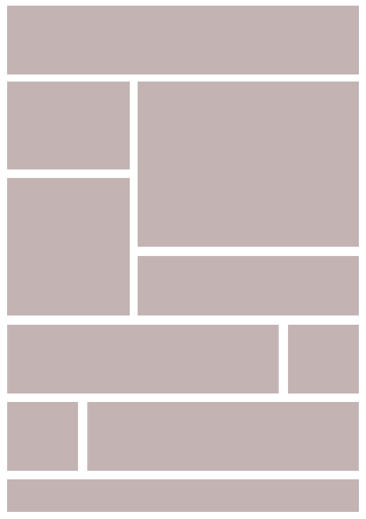

ANALYSIS-
The problem has been solved with the use of FLEX-BOX layouts, in which class “one” has the “display:flex” property which will give all the boxes by default in rows section. Then another class i.e. class “two” holds the other two boxes to keep the boxes align upside down. The flex layout allows responsive elements within a container to be automatically arranged depending on viewport.
Animation is done with the help of “keyframes” and with hover effect. If we hover on any box it will change it’s shape and picture too. To achieving this “Transform: scale(2)” is used which increases the with 2 times and background-image will also change

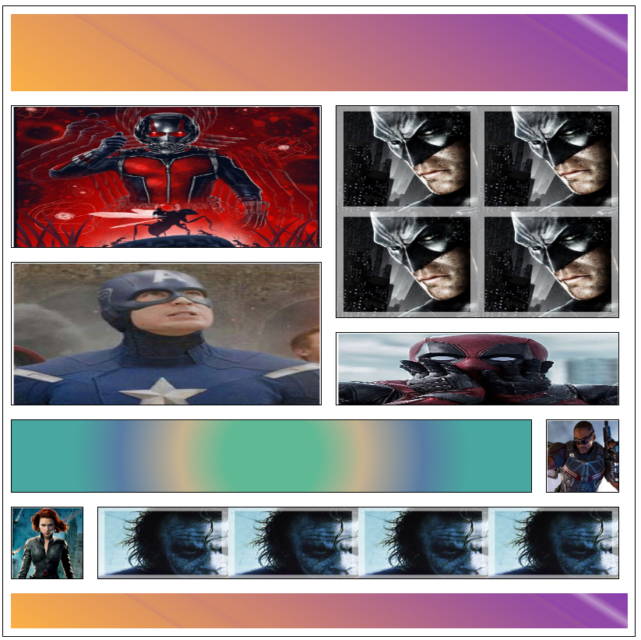
OUTPUT –

